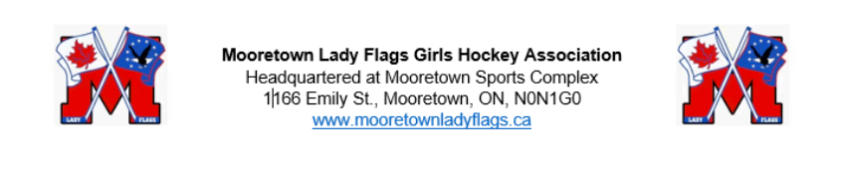Fundraising/Volunteering Information - Mooretown Lady Flags 2024/25 Season
Mooretown Lady Flags Girls Hockey Association is run by volunteers. Our organization actively fundraisers throughout the year, including the off season, to help offset costs like registration, ice, and referee fees. As a parent/guardian of a Lady Flags player, you are expected to complete 8 hours of volunteer work.
Every family that is registered with our organization must submit a $500 post dated volunteer and jersey cheque; this includes coaches, team staff, and members of the Executive. Cheques must be post dated for May 1, 2025. All cheques must be submitted to their teams’ manager by October 1, 2024.
Please note:
- Cheques and volunteer/jersey forms not submitted by October 1, 2024 will result in the player not being permitted to skate.
- If the 8 volunteer hours are not completed per family, the cheque will be cashed.
- If jerseys are not returned to the head coach in a timely fashion and in good condition, then the cheque will be cashed.
***NSF cheques will result in player participation being suspended until all fees are paid in full
Remember: We don’t want your money, we want your time!

Volunteer Expectations
While you are volunteering on behalf of MLFGHA it is expected that you represent our organization in a professional manner while adhering to the MLFGHA Code of Conduct. https://mooretownladyflags.ca/Public/Documents/MLFGHA_Consent_code_of_conduct_waiver_2022.23.pdf

Volunteer Changes from the 2023/24 Season
- ONE bingo representative per team - please email the name of your bingo representative to Elaine Kerwin at volunteer@mooretownladyflags.ca
  - Complete a short training at: https://www.charitablegaming.com/volunteer-training
  - Complete 4 bingos in between September and August (2 hours each)
  - Wear a supplied Lady Flags shirt, black pants, and black shoes
- Time clock/scoresheet hours count towards the 8 hour requirement, as long as the volunteers cover at least 75% of their teams games. Half-ice games are not included in this.

Volunteer Positions (Team)
Coach
Assistant Coach
Trainer
Manager
Parent Bingo Rep - 4 bingos per 12 month period (2 hours each)
Time Clock/Scoresheet - 1 or 2 people that complete at least 75% of their teams’ games.
Note: On ice helpers do not qualify for volunteer hours, only rostered team staff positions will qualify.

Volunteer Positions (Other)
Helping at different fundraising events (Antonios Pizza, Sting Game)
Mooretown Lady Flags Board Member
Tryouts (Spring)

Volunteer opportunities can be found here: https://mooretownladyflags.ca/Pages/1104/2022-23_Volunteer_Opportunities_/

Any questions about fundraising or volunteering can be sent to:
Fundraising: Lauren Fitzgerald: Fundraising@mooretownladyflags.ca
Volunteers: Elaine Kerwin: volunteer@mooretownladyflags.ca

